ONLINE TICKETING SYSTEM
@CREATIVITY THINK (9483175986/7019689991)

ABSTRACT:
The Online Ticketing System is a web application designed to facilitate event ticket sales and management for sports, entertainment, and transport sectors. Users can browse events, select seats, purchase tickets, and receive QR codes for entry, while administrators manage events, seating plans, sales, and analytics. The system integrates real-time seat selection, secure payment processing, and detailed dashboards to provide both operational efficiency and an enhanced user experience. Built with Django, Django Rest Framework, React, pdfkit, and chart.js, it centralizes ticketing operations and provides comprehensive analytics for administrators..

INTRODUCTION OF THE PROJECT:
Ticket sales and event management require a reliable platform to handle bookings, seating arrangements, and secure payments. The Online Ticketing System streamlines this process by allowing users to book tickets online, generate QR codes, and view booking history through a user dashboard. Administrators can efficiently manage events, seating, sales, and analytics using a robust dashboard. The system leverages Django and DRF for backend functionality, React for frontend interactions, pdfkit for QR code generation, and chart.js for visualization, ensuring a scalable and user-friendly ticketing solution..

PROJECT OBJECTIVES:

• Enable users to browse and book tickets online
• Provide real-time seat selection and allocation
• Generate QR codes for seamless event entry
• Implement secure payment processing
• Track booking history via user dashboards
• Allow administrators to add and manage events
• Monitor ticket sales and seating analytics
• Provide a centralized dashboard for administrative control

PROBLEM OF THE STATEMENT:
Traditional ticketing methods involve long queues, inefficient seat allocation, and delayed sales tracking. Manual processes lead to entry delays, mismanagement of seating, and limited analytics for event organizers. The Online Ticketing System addresses these challenges by offering an online platform for secure bookings, real-time seat selection, QR-based entry, and comprehensive sales analytics, ensuring efficiency for both users and administrators..

MOTIVATION OF THE PROJECT:
• Facilitate convenient online ticket purchasing
• Reduce queues and manual ticketing errors
• Ensure real-time seat selection and allocation
• Provide administrators with sales and event analytics
• Enhance user experience through QR code-based entry

BLOCK DAIGRAM OF PROJECT:

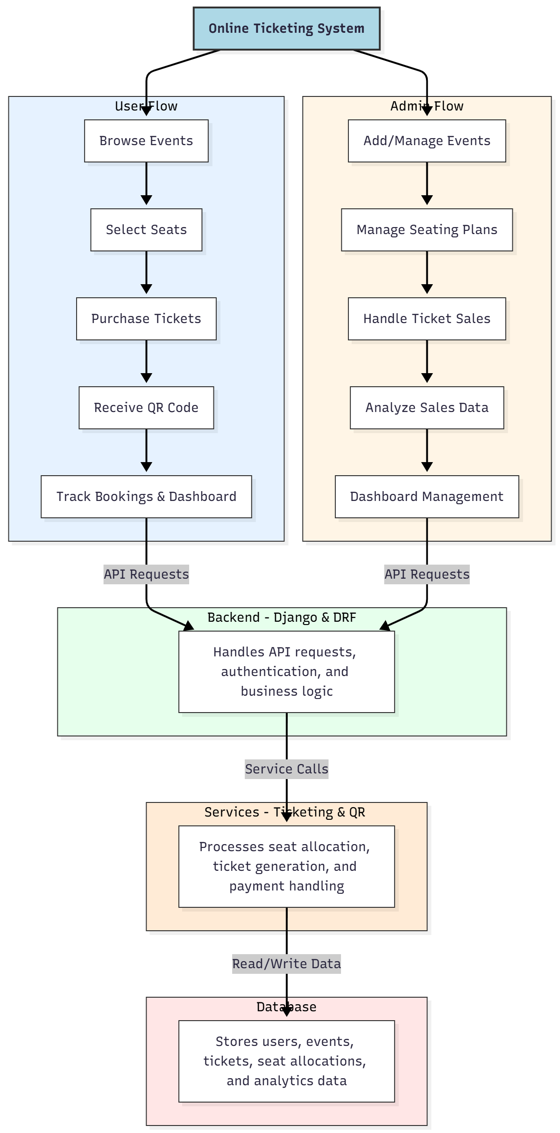

WORKING OF THE PROJECT:
Users browse events, select available seats, complete payments securely, and receive QR codes for entry. They can track bookings and view dashboard analytics. The backend manages authentication, API requests, and business logic, while services handle seat allocation, ticket generation, and payment processing. Administrators add or manage events, oversee seating plans, handle sales, and analyze data through a centralized dashboard to ensure smooth operations and actionable insights..

SOFTWARE REQUIREMENT:
- Backend:
  - Python 3.x
  - Django
  - Django REST Framework
  - SQLite/PostgreSQL
- Frontend:
  - Node.js and npm
  - React.js
  - Axios
- Development Tools:
  - Visual Studio Code
  - Postman (for testing APIs)
  - Git/GitHub (for version control)
- Server/Deployment (Optional):
  - Gunicorn, Nginx, or Heroku/AWS for hosting

ADVANTAGES OF THE PROJECT:

• Enables online ticket booking with seat selection
• Reduces queues and manual ticketing errors
• Provides QR code-based seamless entry
• Real-time payment processing
• Dashboard analytics for users and admins
• Centralized event management
• Improves user convenience and satisfaction
• Scalable for multiple event types

APPLICATIONS OF THE PROJECT:
• Sports event ticketing
• Concerts and entertainment venues
• Transport ticket management
• Movie theaters
• Conferences and seminars
• Festival or exhibition ticketing
• User dashboard analytics
• Administrative event planning and management

REFERENCES:

- Django REST Framework Documentation — Django Software Foundation. Django Documentation. Available: https://docs.djangoproject.com/
- Django REST Framework. DRF Documentation. Available: https://www.django-rest-framework.org/
- React. React Official Documentation. Available: https://reactjs.org/docs/getting-started.html
- Redux. Redux Documentation. Available: https://redux.js.org/introduction/getting-started
- PostgreSQL Global Development Group. PostgreSQL Documentation. Available: https://www.postgresql.org/docs/
- MySQL. MySQL Reference Manual. Available: https://dev.mysql.com/doc/
- Git. Git Documentation. Available: https://git-scm.com/doc
- Node.js. Node.js Documentation. Available: https://nodejs.org/en/docs/
- Axios. Axios Documentation. Available: https://axios-http.com/docs/intro
- Socket.io Documentation – https://socket.io/docs/

